End of Year Expectations for Reception

To support your child’s learning during this coronavirus pandemic, Blackthorn Primary have set out a list of Key Expectations that we expect your child to achieve by the end of each school year. Under normal circumstances, we take responsibility for learning within our school, however, this year more than ever we need your support to ensure your child does not create or widen their knowledge gap within their year group. This leaflet contains a list of 6 Key Concepts that will support your child as they move into Year One. Please work on these concepts with your child over the Summer holidays to ensure a smooth transition back to school in the Autumn Term. Thank you in advance for helping your child be Year One ready!

Maths
- Can recognise, count forwards and backwards up to 20
- Can correctly order numbers up to 10 and count out 10 or more objects
- Can correctly form numbers up to 10

English (Reading & Writing)
- Can use their phonics skills to read and spell CVC words
- Can apply their phonics skills to read and write some longer words
- Recognises some tricky words
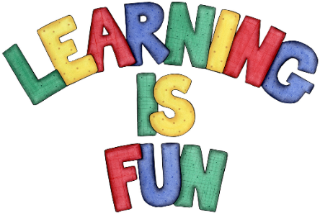
- Form simple sentences These should include: phonetic knowledge for spelling, capital letters and full stops.

