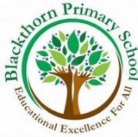

End of Year Expectations for Year One

To support your child’s learning during this coronavirus pandemic, Blackthorn Primary have set out a list of Key Expectations that we expect your child to achieve by the end of each school year. Under normal circumstances, we take responsibility for learning within our school, however, this year more than ever we need your support to ensure your child does not create or widen their knowledge gap within their year group. This leaflet contains a list of 6 Key Concepts that will support your child as they move into Year Two. Please work on these concepts with your child over the Summer holidays to ensure a smooth transition back to school in the Autumn Term. Thank you in advance for helping your child be Year Two ready!

English (Reading & Writing)
- Read the first 200 High Frequency Words and begin to spell as many as possible.
- Read all Set 1/2/3 sounds and use this knowledge to spell unfamiliar words phonetically.
- Write a number of sentences to form short stories, punctuate these with a capital letter and a full stop.
Maths
- Count to and across 100; forwards and backwards from any given number.
- Learn by heart your number bonds to 10 and related subtraction fact (Too easy? Try to 20).
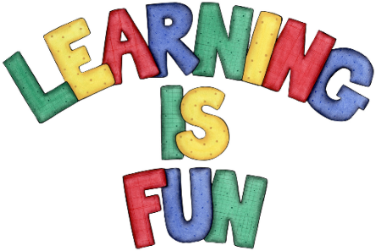
- Count in multiples of 2 / 5 / 10.

