Read Write Inc. Sounds
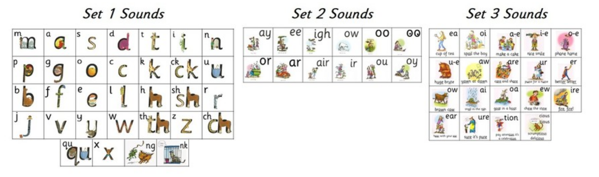

Helpful Read Write Inc. Youtube Links
https://www.youtube.com/watch?v=bXOJUPNVnLc&list=PLDe74j1F52zSCiOMSn3zQDSzgu9TrbQ1c&index=7
https://www.youtube.com/watch?v=TkXcabDUg7Q

High Frequency Words
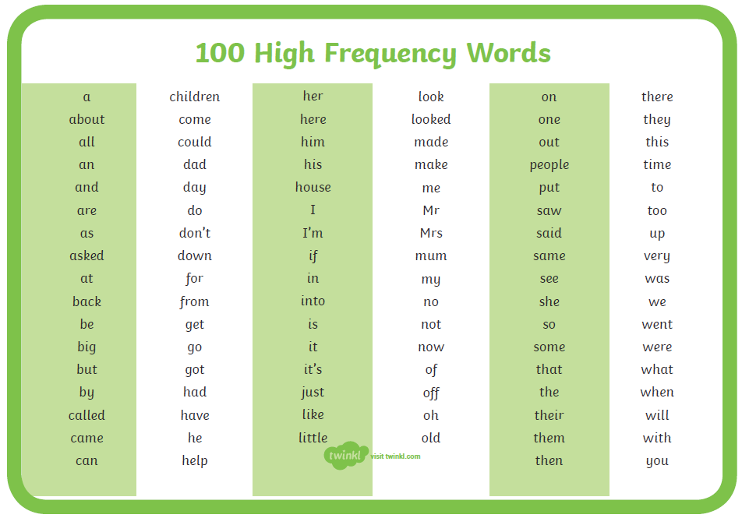

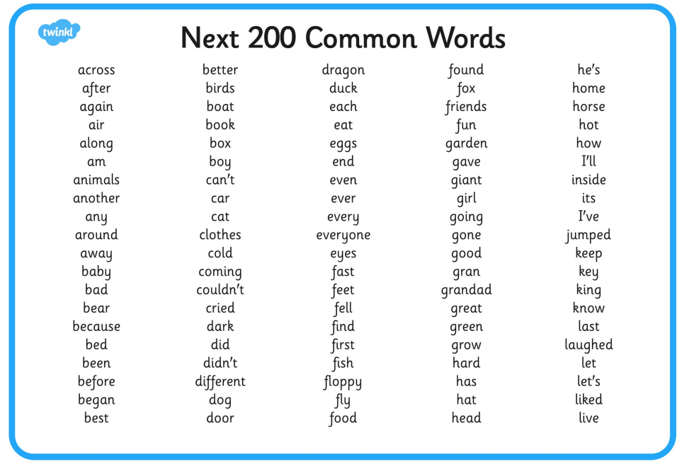

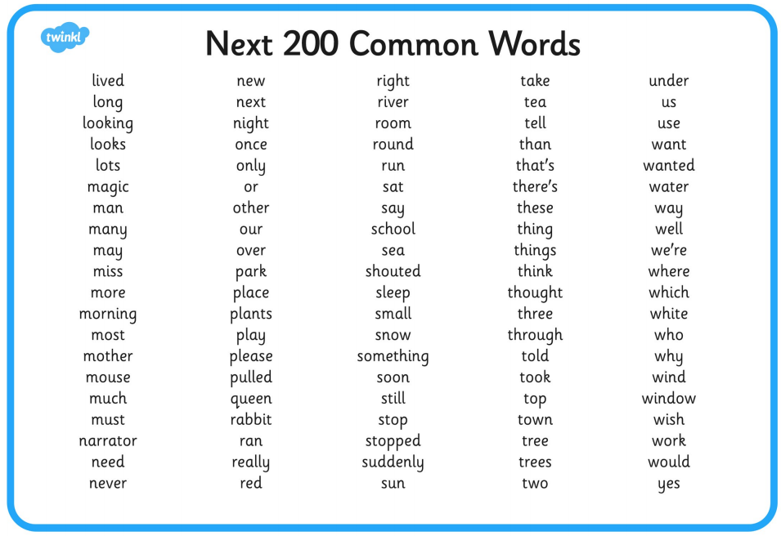

100 Square
